Class Exercises:

Fatima Khan- 210101060

# Python Data Types

# Python List

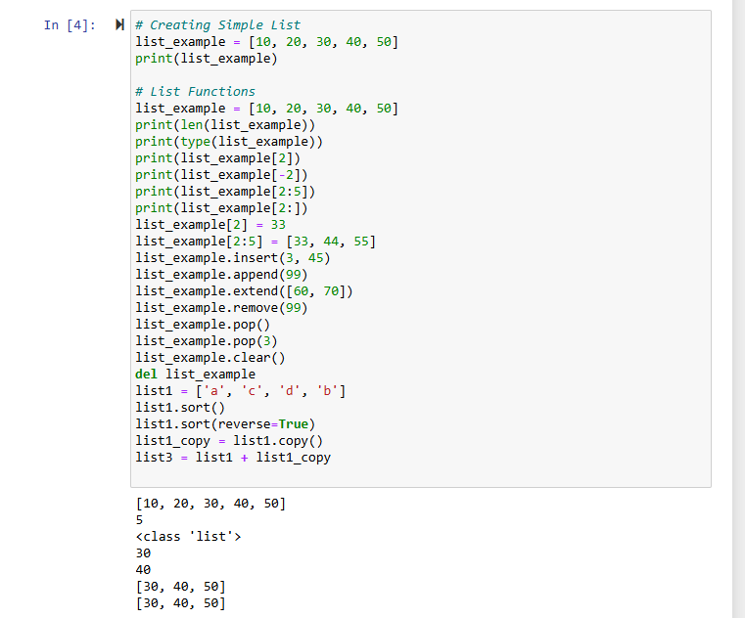

# Tuple Exercises

# Math Functions

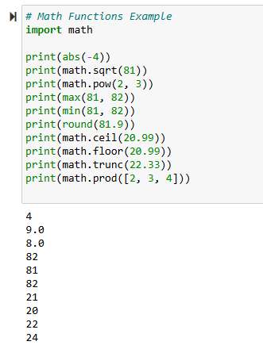

# Python oops exercise

# Python Class Example

# Pandas

Additional Exercises

# Matplot

# IO File

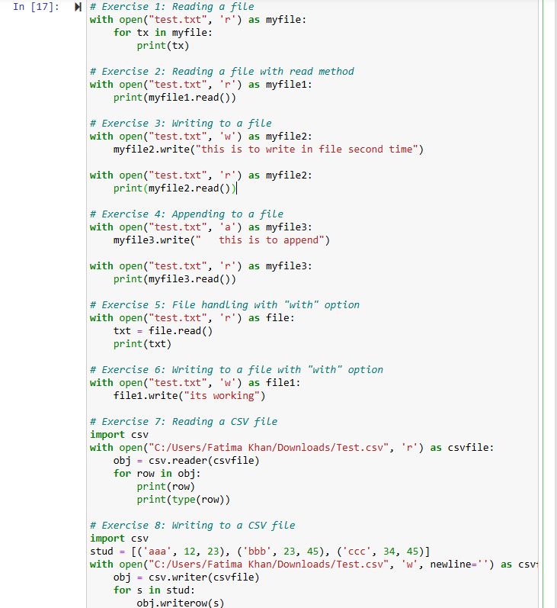

# Numpy Array 1

# Numpy Array

Code Corrected:

